 | REQUEST FOR  ENROLMENT MODE CHANGE | 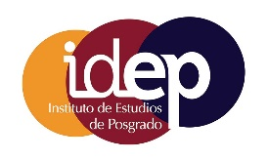
 | Applications are to be submitted through the University of Cordoba's Electronic Office in accordance with the General Application process, addressed to “ESTUDIOS DE DOCTORADO”

PERSONAL AND ACADEMIC DATA OF THE DOCTORAL STUDENT

SURNAME(S): | NAME: |  | NIF/NIE/PASSPORT NO.:
EMAIL: | PHONE: | NATIONALITY:
FULL ADDRESS (Street; Postal Code; City; Province; Country):

PHD PROGRAM:

CURRENT ENROLMENT MODE

☐ | FULL-TIME | ☐ | PART-TIME

ENROLMENT MODE REQUESTED

☐ | FULL-TIME | ☐ | PART-TIME

Reasons for the change in enrolment mode:

DOCUMENTATION ATTACHED (It is mandatory to provide documents that justify the change in enrolment mode):

The doctoral student
Signed: | ________________________ Name and Surname(s)

The Doctoral Program Academic Committee mentioned above, meeting in ordinary session,
☐ | HEREBY AUTHORIZES | ☐ | DOES NOT AUTHORIZE

the change in enrolment mode requested.

Signed: _________________________
Coordinator of the Doctoral Program Academic Committee

